Inflation in an Island of High Prices. The Factors behind Price Stability in Switzerland
Celâl Güney, Guillaume Dreyer, Michalis Nikiforos

Abstract
In the context of more frequent supply shocks, this article assesses the factors behind the relative resistance of Switzerland to cost-push inflation. We first review and assess common explanations behind price stability of the Swiss economy, namely the strength of the Swiss franc, the construction of the country’s consumer price index (CPI), the importance of the high share of administered prices in the CPI basket. Based on the result of a Leontief price model on a 50 industries input-output table of the Swiss economy, we then show that key sectors for Swiss price stability are sectors with substantial price administration, namely transport, food manufacturing and electricity & gas. We thus find that low inflation in Switzerland is the result of a combination between the regulation of the energy sector, the protection of the domestic agricultural sector and structural change which has improved the energy mix and intensity of the economy. Finally, we explore the socio-political coalition behind the existence of the Swiss high price island.
Keywords: Inflation, Switzerland, Supply Shocks, Price Stability, Administered Prices

Introduction
With the recurrence of large-scale global supply shocks since the Covid-19 crisis such as the war in Ukraine and more recently the closure of the strait of Hormuz, inflation has made a strong return in developed economies (Baltensperger 2023; Honohan 2024). In the last few years, countries have experienced inflation rates not seen in decades due to supply chain disruptions and the increase in gas and oil prices. However, one country has remarkably well resisted to the 2021-2023 inflation surge: Switzerland. According to the KOF Swiss Economic Institute, inflation rose up to barely 2,8% in 2022 and 2,1% in 2023 and, since 2024, is already back to the Swiss National Bank (SNB) target range (0-2%) since. In international comparison, inflation reached 8% in the United States and 8,4% in the Eurozone in 2022 before declining to 4,1% and 5,5% respectively in 2023 (Sturm et al. 2023). The harmonized food price index increased by only 4,2% in Switzerland during the global food crisis of 2022 whereas it increased by 16,7% in the European Union (EU) (Eurostat 2026). As shown in figure 1, Swiss headline inflation rates are consistently lower than the OECD and the United States. Whereas the Swiss economy was still subject to high inflation during the 70s and 80s, the long run tendency is characterized by a trend toward strong price stability, even deflation. The latter was particularly important after the Great Recession and became a policy issue during the 2010s, so much that the Swiss National Bank (SNB) introduced several unconventional monetary policies to fight deflationary pressures on the Swiss franc (more about the so-called “taux plancher” below). Among rich economies, only Japan has displayed such comparable deflationary trends.
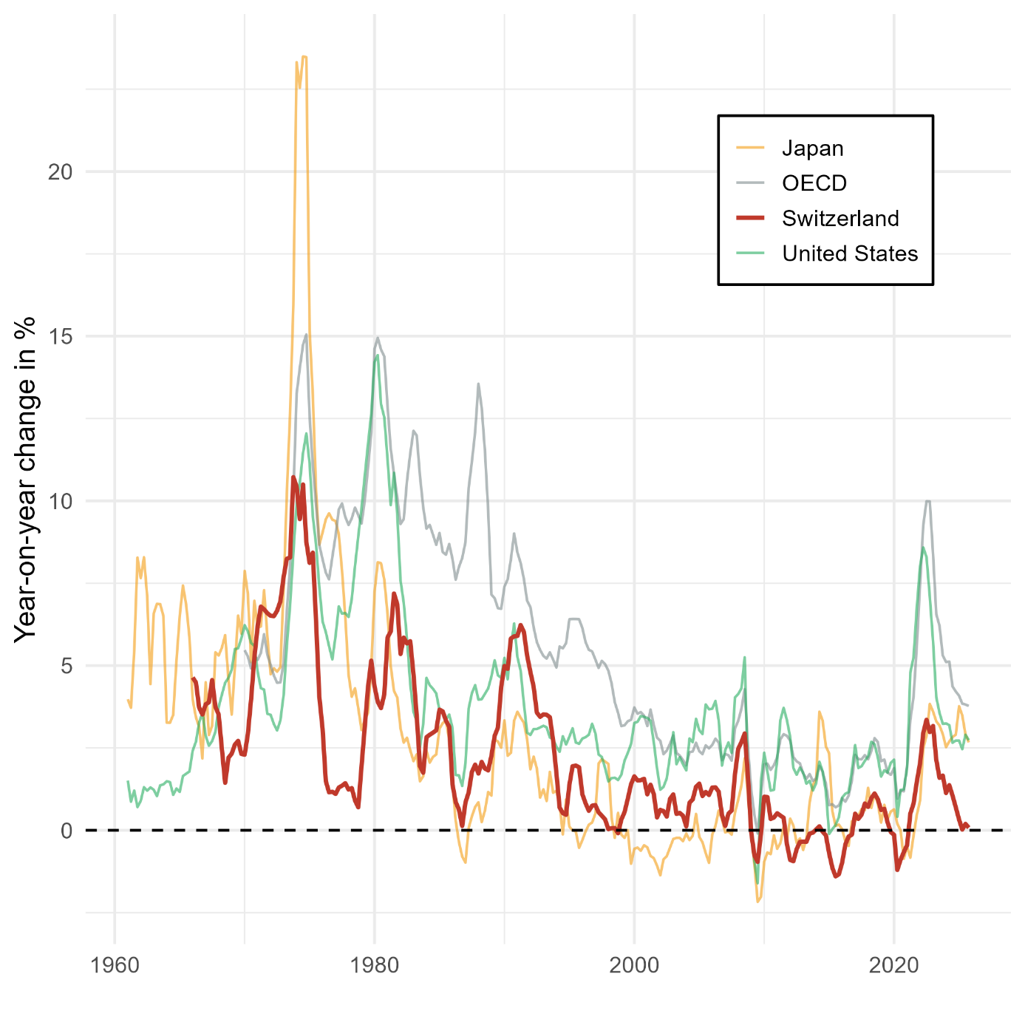
At the same time, Switzerland has one of the highest price levels in the world. Its GDP price index is approximately 60% higher than the EU average and final household expenditure prices are higher by 82% (Albouy and Bordes 2026), which contribute to Switzerland being characterized as an “island of high prices” due to its relatively very high price level.
Figure 1: Headline inflation rates in Switzerland since the 1960s compared to overall OECD countries average, Japan and the United States. Source: OECD Economic Outlook.
What factors lie behind the high price levels and low inflation rates in Switzerland? What makes this country particularly resistant to inflationary pressures? The present contribution aims to contribute to the current debates around the return of inflation through an assessment of the institutional characteristics of the Swiss socio-economic model as well as its policy instruments which make it robust to inflation. Regarding the debates, there are two main currents in that regard. On the one hand, New Keynesians or New Consensus macroeconomists view inflation as the result of excess demand, that is, when there is a positive gap between actual GDP and potential GDP. According to this approach, the inflation of the 2020s is the result of either the fiscal and monetary stimulus in the aftermath of the Covid-19 crisis, or the result of a wage-price spiral. On the other hand, heterodox economists from post-Keynesian and institutionalist strands view inflation mainly as a cost-push phenomenon triggered by supply shocks affecting sectors with systemically significant prices which propagate more strongly to the rest of the economy such as energy (Weber et al. 2024, 2026). Whereas neo-Keynesians advocate restrictive monetary policy to reduce aggregate demand to fight inflation, heterodox economists propose more encompassing set of policies and reforms such as maintaining strategic reserves and implementing buffer stock systems to fight price fluctuations. Among those policies, price control is arguably the most salient instrument in that regard, as it is considered a relevant measure to contexts in which inflation is driven by increases in the mark-ups of firms in highly cartelized and non-competitive sectors which take advantages of the scarcity of raw materials in times of shortage crisis. With respect to unconventional policies, the Swiss economy is a particularly compelling case study. Despite its very conservative and monetarist central bank, the Swiss economy is characterized by its very high share of administered prices in key sectors such as energy and transport, a feature which is often interpreted as a proof of active price control policy by the Swiss government. Switzerland is also one of the few European countries which actively maintain strategic reserves for key commodities.
The paper is structured as follows. The first section reviews the literature on the factors behind Switzerland’s low inflation and high price level. Using the concept of systemically significant prices as well as the results from a Leontief price model, the second section analyzes how price regulation operates in key sectors of the Swiss economy where oligopolistic power and/or systemically significant prices rule.

Literature Review
Due to the relative lower importance of inflation in Switzerland, the scientific literature on the determinants of the country’s inflation dynamics is rather scarce. One can nonetheless identify several types of explanations: the strength of the Swiss franc, the construction of the Swiss CPI, and the role of price administration.
The first type of explanation, and surely the most widespread one, associates low inflation rates to the strength of the Swiss franc which dampens the price of imported goods. One of the most salient stylized facts of the Swiss economy is in effect the structural tendency of the Swiss franc to appreciate since the end of the Bretton Woods system, a tendency which reflects the country’s high competitiveness of its export-oriented industries which creates a sustained international demand for Swiss francs (Reynard 2009; Vallet 2016). Another variant of this explanation resides in the status of the Swiss franc as a strong safe-haven currency. The Swiss franc is indeed considered as one of the most sought-after assets in times of financial and economic crisis (Fatum and Yamamoto 2016; Lee 2017). Baltensperger and Kugler (2016) dates the status of the Swiss franc as a safe-haven currency back to the first World War, when this status mirrored Switzerland’s strong political, economic and monetary stability. For Swiss economic organizations and policy makers, the appreciation of the Swiss franc is considered as a double-edged sword. On the one hand, it represents a threat on the export-oriented industries which fear that an overvalued franc might a negative effect on Swiss exports abroad. This fear is also shared by industries mostly oriented towards the domestic sector such as retail which are afraid that higher relative prices will result in an increase in cross-border shopping, a phenomenon that can be important in Switzerland given its geographical proximity to important European countries with a much lower cost of living (Kluser 2025). On the other hand, a stronger currency implies cheaper imports and can thus help to mitigate inflation, especially since Switzerland is a small open economy with few natural resources and therefore highly dependent on imports. The SNB even considers that appreciations of the Swiss franc come with the risk of provoking a deflationary spiral in times of economic crisis. During the eurozone crisis, the SNB introduced a minimum exchange rate (the so-called “taux plancher”), of one franc against 1,2 euros to prevent deflation. The fact that the zero lower bound for the policy rate had already been reached entailed substantial purchase of foreign currency by the SNB which substantially increased its balance sheet until it decided to abandon the minimum exchange rate in January 2015.
Studies on the so-called exchange rate pass-through (ERPT) on inflation have nevertheless consistently found only a limited effect in Switzerland. Stulz (2007) estimated a substantial but incomplete pass-through on import prices, with ERPT elasticities of 0,52 after twelve months and 0,37 in the long run, whereas ERPT to consumer prices amounts to 0,09 in the short run and merely 0,18 in the long run. Using monthly data between 1999 and 2010, Herger (2012) found that the ERPT elasticity onto aggregate import prices is only 0,3. Other studies have found either small or insignificant ERPT effects. Even studies that have examined the causal effect of the sharp and sudden appreciation of the Swiss franc following the removal of the minimum exchange rate in 2015 have found only a limited impact. Auer et al. (2021) found a one-year pass-through effect of 0,075 for retail domestic prices and 0,366 for retail imported products. The results of Oktay (2022) underlined important heterogeneities in the pass-through across categories of goods and services, with non-tradable goods and services having lower pass-through than tradable ones. However, the aggregate result of the pass-through is found to be very small as only 12% of the euro/franc shock of 2015 was passed on the overall Swiss consumer price index. Low inflation rates in Switzerland cannot therefore be attributed solely based on the strength of the Swiss franc as the ERPT effect is in fact very limited.
However, a low ERPT does not necessarily imply that movements in the exchange rate and the price of imports are of no importance regarding inflation dynamics in Switzerland. The results from a historical decomposition of a structural vector error correction model by Leutert et al. (2026) showed that, whereas increases in unit labour costs (UCL) had only a modest impact on CPI inflation in the last 40 years, variations in import prices due to oil price shocks, foreign inflation and the exchange rate explain a substantial part of Swiss CPI movements since the 1980s. This indicates that even though import prices have a low pass-through, they remain important drivers of inflation dynamics in Switzerland. On the other hand, the very limited pass-through of UCL on CPI inflation can be explained by the fact that Swiss ULC are more relevant for export prices than for domestic consumer prices as most items of the latter are composed by categories which only marginally depend on labour input for instance rents and health which account for around 40% of the Swiss CPI) (Leutert et al. 2026, 11).
Some comparative case studies hold that lower inflation rate in Switzerland can be explained to a considerable extent by the different weights assigned to the items of the CPI compared to other countries, implying that Switzerland's low inflation is in part a statistical artefact, reflecting the specific structure and expenditure weights of the Swiss CPI basket. These studies underlined the relatively low weight assigned to energy (5%) and the exclusion of certain important expenditure items such as the compulsory health insurance premiums and have provided estimations of Swiss inflation using the expenditure weights applied in other countries such as Germany. Under these counterfactual weighting schemes, Swiss inflation remains nonetheless substantially lower than in other economies as it gains only 1 to 2 percentage points (Sonnenberg 2022; Dullien et al. 2024). The dynamics of the CPI remains furthermore the same, as only its level is changed under the re-weighting calculation. The weighting differences are thus not a great explanation of Swiss price dynamics and the relative resistance of the latter to inflationary pressures.
Regarding the structure of the Swiss CPI, another line of explanation has emphasized the importance of the high share of administered prices in the basket as a factor behind Switzerland’s price stability. The share of administered prices, defined as prices set or regulated by the government that are not determined solely by market supply and demand, is particularly high in Switzerland as it represents around one-quarter of the CPI. In 2025, the share of administrated prices in the harmonized consumer price index was 25% in Switzerland, compared to around 12% in the European Union. The fact that one third of Swiss prices are administered naturally raises the hypothesis that the Swiss government exercises substantial price controls to keep inflation low. However, the scarce literature on this topic supports that administered prices are not an important driver of low inflation in Switzerland nor a significant factor to explain Switzerland’s inflation gap in comparison with the euro area. On the one hand, despite the importance of administered prices in the Swiss CPI basket, an indicator of inflation excluding them would not have changed substantially price dynamics in the country over the last 20 years, as CPI inflation excluding administered prices was only 0.1 percentage points higher than CPI inflation including them. On the other hand, both administered and non-administered prices increased considerably less in Switzerland than in the euro area. This suggests that inflation gap between the two economies cannot be attributed solely to administered prices, but must also reflect differences in the evolution of non-administered prices (S. Auer et al. 2025).
In place of a deliberate policy designed to control price level and inflation, the high share of administered prices rather reflects in great part Switzerland’s peculiar welfare state system, notably its mandatory health insurance system. Unlike other European countries where all health services and products covered by mandatory health insurance are directly taken in charge by the state, Swiss residents must finance by themselves a great part of health expenditures through out-of-pocket payments until a minimum franchise is reached in addition to the premiums which are not taken into account into the Swiss CPI basket. As a result, the 25% share of administered price is artificially inflated by a high share of health goods and services (around 14%) which are administered as they are covered and thus regulated by the compulsory public plan, but whose expenses must still be supported through out-of-pocket payments by households. In contrast, the share of products and services with administered prices for other key items are significantly lower: 3% for energy or 2,3% for transports (S. Auer et al. 2025; Mergele et al. 2026).

The role of price administration in systemically significant sectors
Does price administration truly play no role behind Switzerland’s resistance to inflation? In this section, we show that the arguments against a substantial effect of price administration on price stability in Switzerland outlined in the previous section do not hold when we account for the fact that price administration is present in sectors with systemically significant prices. We cannot evaluate the impact of administered price simply by comparing the differences in level and evolution of an administered prices-free CPI and one excluding them as such an approach overlooks prices interrelationships and potential cascade effects through the cost structures of the economy. This is especially relevant when price administration operates in sectors with systemically significant prices. In the context of price stability, the concept of systemically significant prices developed by Weber et al. (2024) (after Hockett and Omarova (2016)) refers to prices which have a considerable impact on the general price level measured by the CPI. Prices should not therefore be analyzed in isolation, but as part of a complex interdependent input-output system in which shocks to some prices matter more than others since they will have a greater impact on overall inflation due to the ubiquity of their products. The interest of this approach is thus to identify specific points of vulnerability among prices that matter the most for inflation, considering the cost relationships between sectors.
The foundational study by Weber et al. (2024) captured these cost-prices interrelationships using a Leontief price model on input-output table for the US economy in which they ran simulation shocks to explore how price volatility in each sector propagates through indirect and direct effect on CPI inflation. The results of their simulations of price shocks identified petroleum & coal and oil & gas as the most systemically significant prices considering their price volatility for the period 2000-2022, followed by other items such as food, farming, chemicals, housing or wholesale trade. In other words, they group three types of systemically significant sectors: those essential for human livelihood such as food, housing and utilities; those providing for the infrastructure of commerce such as wholesale trade; and those that provide key production inputs like oil, petroleum and chemicals. This typology of systemically significant sectors as well of their overall results were confirmed in subsequent studies for instance by Weber et al. (2026) for the German economy and Goldztejn (2024) for France. Using the World Input Output Database rather than national input output tables, Ipsen et al. (2025) ran cost-push stress tests to estimate shockflation exposure within the European Union (EU), distinguishing asymmetries of exposures between the EU core and periphery. On the one hand, they found that common systemically significant sectors in both the core and periphery include real estate activities, energy provision, financial services and food manufacturing. On the other hand, real estate is relatively more significant in the core while energy supply and production matter more in the periphery.
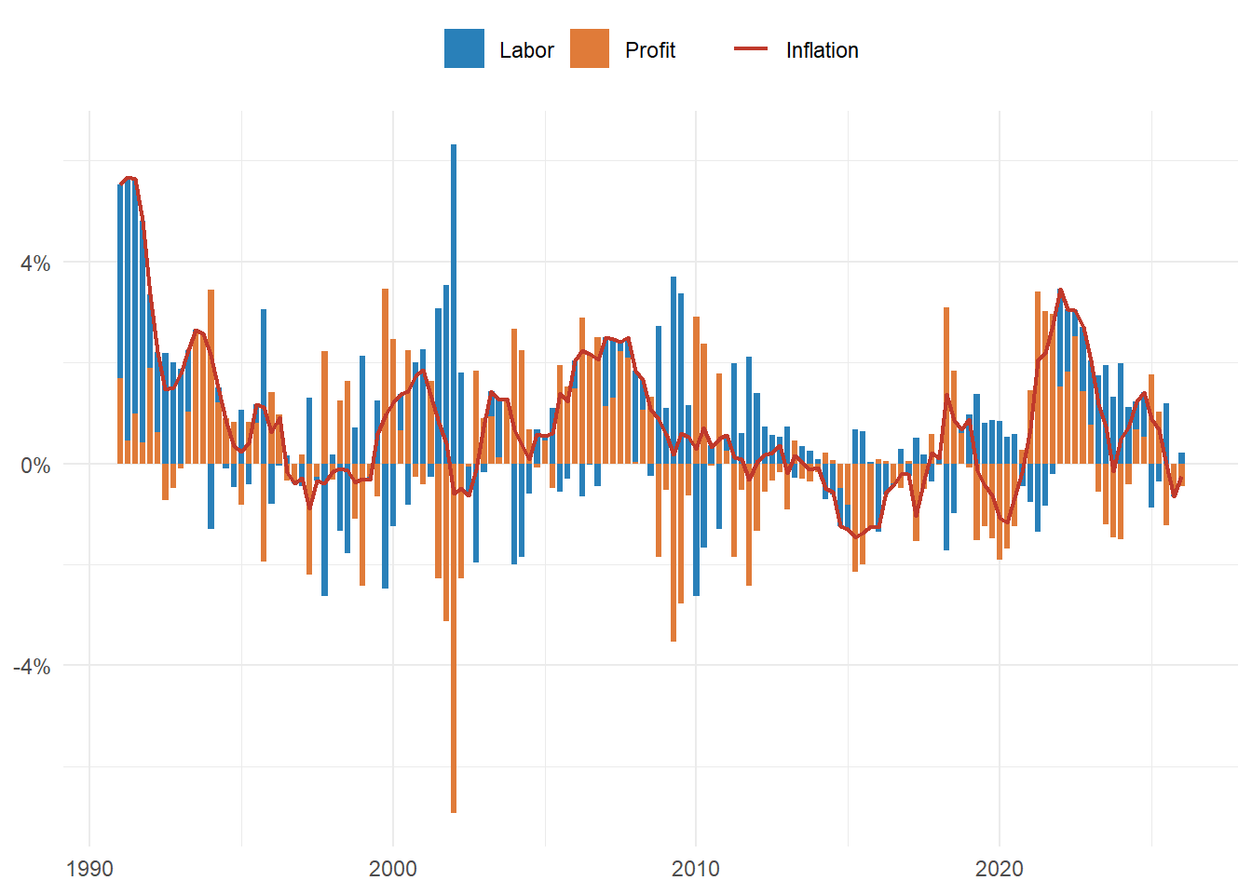
Sectors with systemically significant prices play a great role in the process of sellers’ inflation which has been documented in the United States by Weber and Wasner. They showed that commodity price shocks in significant upstream sectors can trigger price hikes by firms with market power which can take advantage of bottlenecks in times of crisis and supply chain disruption to maintain or even increase their margins. Their decomposition of inflation as measured by the GDP deflator into profit and wage components in the United States showed that most of inflation during the 2020-2022 period was captured by nominal profit increases due to price hikes.
Figure 2: Capture of annual inflation by profits and wages. Inflation is measured as percentage change in the gross value added (GVA) deflator (red line). Source: Author's own elaboration based on data from the Swiss Secretariat of Economic Affaire (SECO).
As shown in figure 2, the same phenomena can be observed in Switzerland during the same period. This figure shows how much of the nominal change in the Swiss gross value added (GVA) attributable to inflation is captured by labor in the form of wages and by capital through nominal increases in profit flows. During the period 2020-2022, profits as measured by gross operating surplus accounted for 12,6% of the 5,4% increase in the inflation rate of the GDP deflator, while compensation of employees accounted for -7,2% of the increase. Conversely, deflationary periods tend to be characterized by decreases in nominal profits and positive rate of increase of nominal compensation of employees, for instance in 2014-2017 and 2019-2020.
This stands in sharp contrast to the economic crisis of the 1990s, when most of inflation was captured by increases in nominal wages. As indicated by Leutert et al. (2026, 13), wage-price pass-throughs were higher before the 2000s due to a higher wage indexation and higher union coverage rate. This indicates that sellers’ inflation was also prominent in Switzerland during the energy crisis of 2021-2022, albeit at a lower intensity than in other countries since the overall inflation rate was much lower than in other countries. Our hypothesis is that sellers’ inflation was dampened by direct as well as indirect price administration in critical sectors of the Swiss economy, making the latter more robust to the energy and food crisis of that period.
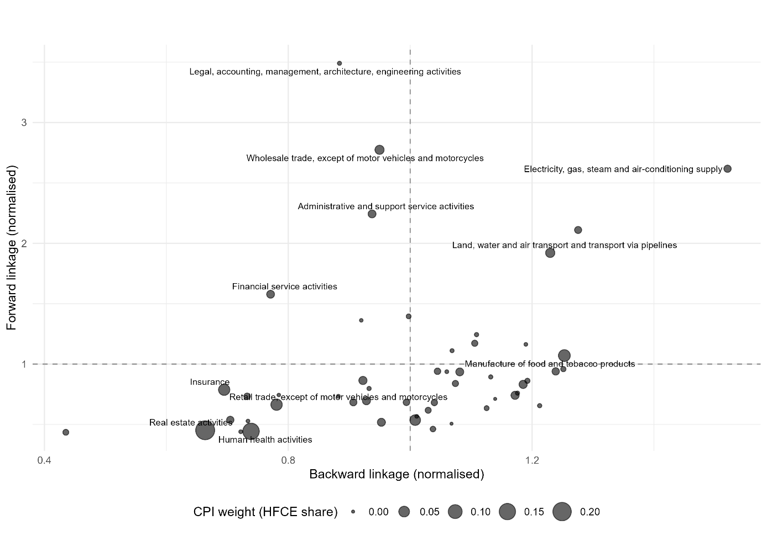
We test this hypothesis by applying a Leontief price model on the 2017 Swiss input output (IO) table provided by the Federal Statistical Office (FSO) which is the most recent publicly available table and contains information on 50 industries. We first compute the Leontief matrix and sum up the rows and columns of its inverse to estimate forward linkages (FL) and backward linkages (BL) for each sector which are shown in figure 3.
Figure 3: Forward and backward linkages for each sector. Point size represents the magnitude of the weight of each sector in a synthetic CPI computed from data on household final consumption expenditure (HFCE) available in the input-output table. Data source: FSO
Figure 4: Systemically significant sectors for price stability in Switzerland. On the left (a): effects of a sectoral unit price increase on a synthetic Swiss consumer price index. On the right (b): forward linkages and CPI inflation impact of sectoral unit price shocks in the Swiss economy. Data source: OECD input-output tables.
From figure 3, we can identify the following categories of sectors. On the bottom-left quadrant, we have sectors which are independent from inter-industry linkages due to their low FL and BL but are key for price stability since they represent a high share of consumers’ expenditures. Such independent but key sectors are real estate activities (20% of synthetic CPI weight), human health activities (15%), insurance (10%) and retail trade (10%). On the upper-right quadrant, we have key sectors with high FL and BL, which include the electricity and gas sector and transport. Taken together, they represent around 10% of the synthetic CPI’s weight. It is therefore interesting to note that the sectors which are crucial for Swiss price stability due to their high share in consumers’ expenditure are relatively independent from inter-industry linkages. Food manufacturing is also an important sector with high BL and high weight in the CPI.
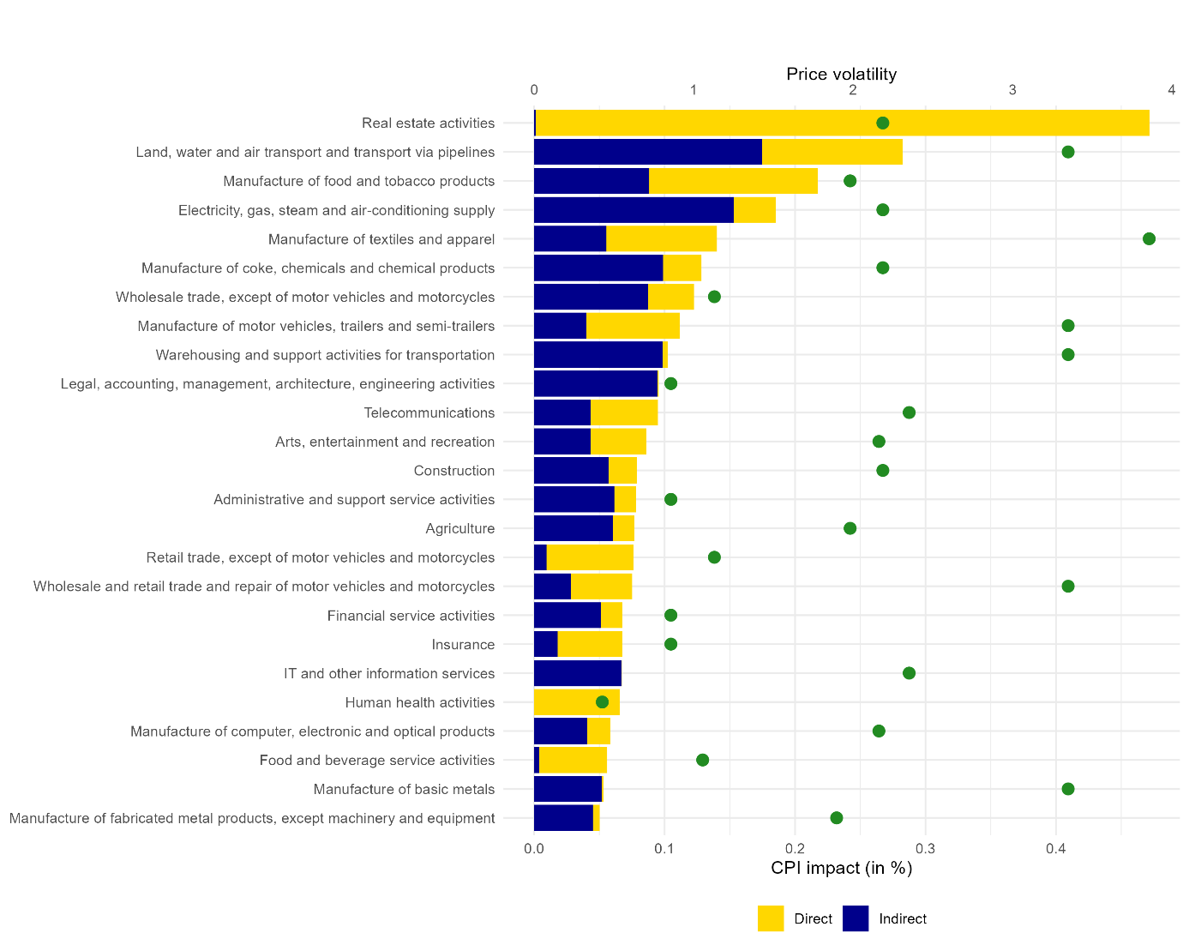
As in Weber et al. (2024), we simulate the impact of a price increase in each sector on a synthetic CPI using sector average price volatility, defined as the standard deviation of a given sector’s yearly percent price change. We use Swiss price data from Eurostat’s harmonized consumer price index (HCPI) for the period 2004-2025. The results are shown in figure 4. Price shock in the real estate activities sector is by far the most important, followed by transport, food manufacturing and electricity and gas. In accordance with the results of Ipsen et al. (2025), the sector of real estate activities is the most significant. The substantial inflationary effect of a shock to real estate activities can be explained by the very large share of rents in Swiss consumers’ expenditures due to the general upward trend in rents. The Swiss housing market suffers in effect from excessive demand and a housing shortage as illustrated by the country’s very low vacancy rate of 1%, which is even lower in Urban centers such as Geneva (0,34%) and Zurich (0,48%) (Tschirren 2026). Between 2000 and 2024, residential rents increased by 38% according to the Swiss consumer price index, the large share of which is explained by demand-side factors. Whereas rents are determined by supply and demand, the Swiss housing market is considered by the Swiss Secretariat of Economic Affairs (SECO) as a market whose prices are indirectly administered due to several regulations on the supply-side (Mergele et al. 2026). Transport and electricity prices are on the other hand directly administered by public institutions at the federal, cantonal and even communal levels. Price administration thus plays a key role in regulating prices in key sectors for inflation as well as in sector whose consumption share in the CPI is large such as insurance and health activities (as explained above for health products). Regarding food manufacturing, the price of food products is influenced by two factors: the strong degree of protection of the domestic agricultural sector and the importance of a particular duopoly in the Swiss domestic economy which originally formed in the retail sector: that of Coop and Migros.
Figure 5. Inflation impact from price-shock simulations for the top 15 sectors using a Leontief price model. The magnitude of the price shocks (green dots) corresponds to the sector's average price volatility over the period 2004-2025. Data source: FSO, Eurostat.

Oligopolistic power and regulations in the domestic sectors: the case of retail and agriculture
Whereas Switzerland is widely known for its multinationals specialized in international commodity trading such as Glencore and Trafigura; its pharmaceuticals or chemicals industries, the key role played by retail companies oriented towards the national domestic market is far less known. More specifically, the Swiss national retail sector is dominated by Coop and Migros, two large cooperatives which have a firm hand on the Swiss market. It is indeed hard to overstate the importance of these two firms on the Swiss economy: they are by far the country’s largest private employers; each has more than two million cooperative members; and they are deeply rooted in Switzerland’s history, society and national identity. Migros is for instance Switzerland’s largest private employer with around 91700 employees, 88% working in the country. It plays also a great role in training the Swiss labor force as it employs on average 3300 apprentices trained across more than 50 different professions.
In addition to its activities in food retail, the Migros Group also owns numerous subsidiaries operating in non-food retail, healthcare, tourism, as well as in the banking and education sectors. The Migros Group operates not only in the service sector but also in the production sector, as the factories of Migros Industry produce most of the food products sold in Migros supermarkets. Migros also has its own bank (Bank Migros) and provide courses and training programs (“Klubschule” or “École-club Migros”) at around 50 different locations throughout Switzerland, courses which are sometimes funded by unemployment insurance itself as part of professional reintegration programs. In recent years, the Migros Group has divested numerous brands and retail subsidiaries as part of a strategic refocusing effort, particularly toward e-commerce, driven by the success of Digitec Galaxus, its online retail subsidiary, which has established itself as Switzerland’s leading e-commerce platform since the COVID-19 pandemic (Nod and Irminger 2026).
Coop is the other historic giant of Swiss retail and Migros’s main competitor in the domestic market. While this cooperative traditionally operated in Migros’s shadow and was long regarded as the number two of Swiss retail, its growth in recent years has enabled it to surpass Migros in terms of turnover and market share in the food retail sector. Coop has a structure and profile similar to those of Migros, with a few notable differences: Coop has become more heavily involved in wholesale trade following its acquisition of Transgourmet, one of Europe's leading foodservice and wholesale distribution companies, and is therefore less diversified than Migros in terms of its range of business activities. Nevertheless, it still owns a wide portfolio of retail brands in both the food and non-food sectors, as well as several food production businesses (Sutter and Wyss 2026). It is thus not surprising that the most significant sector of the Swiss economy is Wholesale & retail trade.
What is the effect of this duopoly on Swiss price dynamics? On the one hand, Coop and Migros have been criticized for allegedly excessive margins that they are able to extract thanks to their oligopolistic power. By controlling both processing and distribution, they enjoy significant leverage in negotiations, particularly regarding the prices of agricultural products, which has fueled dissatisfaction among Swiss farmers. These farmers, politically represented by the Swiss Farmers’ Union (SFU), have been joined in their criticism by other stakeholders, including the Fédération Romande des Consommateurs (Romandie Consumers’ Federation), the press, and the national public broadcaster RTS. RTS, for its part, has sought to assess directly the margins of the two major retailers through numerous investigations conducted in recent years. One investigation published in 2023 highlighted what it described as “sometimes staggering price gaps between the prices paid by Coop and Migros and the prices charged on store shelves”, with gross margins on food products reportedly ranging from 50% and 80% to as much as 110%.
This substantial market power enjoyed by Migros and Coop is the result of a long tradition of protection of the Swiss domestic sectors. The Swiss regulatory framework of its retail sector has long protected Coop and Migros from foreign competition: Swiss law restricts the opening of large stores above 10’000 sqft; food safety and packaging regulations are very restrictive; direct democracy also allows citizen to oppose any planned openings and thus the latter can be refused or take a long time. The three languages of the country: French, German and Italian; and the strong federalist structure of Switzerland’s political institutions as well as its strong decentralization into 26 different cantons each having its own laws are additional administrative barriers which deter potential foreign competitors to Coop and Migros (Morschett et al. 2009).
The agricultural sector which frequently denounces the margins of the Coop-Migros duopoly is also heavily protected and regulated. Swiss agriculture would indeed not survive without the federal agricultural policy whose budget allocation for agriculture amounts to 3,4 billion francs per year, making Swiss agriculture one of the most subsidized among OECD economies. Swiss agriculture is also strongly protected from foreign competition: the average most-favored-nation tariff on agricultural imports in 2023 was according to the World Trade Organization (WTO) at 28,5% whereas it was at 1,3% for non-agricultural products in 2023. Tariffs on agricultural products were particularly high for live animals and meat (97,7%) and for dairy products (129%) (WTO 2024, 173).
Switzerland has indeed a long tradition of strong border protection for agricultural products through import quotas. After the Uruguay Round, (seasonal) tariff rate quotas (TRQs) have become the main import protection tool to support farm income by keeping domestic producer prices high and to ensure domestic food supply. As a result, the OECD considers the level of price distortion of the Swiss agricultural sector to be one of the highest among OECD economies with a producer nominal protection of 1,56, meaning that Swiss farmers receive prices that are overall 56% above international market level (OECD 2025). A study by Judith Hillen on tomato prices under seasonal TRQs suggests that this system guarantees high but stable prices for vegetables products, but generates quota rents which are most likely captured by the large retail companies (Coop and Migros) as they are the holders of import quotas (Hillen 2019, 871).
In response to these accusations, Coop and Migros have put forward their cooperative structure which impede the two giants from generating profits and allegedly encourage them to pursue the interests of Swiss consumers. In their communication strategies, Coop and Migros furthermore claim to be engaged in "price wars" in order to remain attractive in the face of the two discount outsiders, Aldi and Lidl. They allegedly claim that price reductions are regularly implemented across hundreds of products, and that these reductions are absorbed through lower margins on their side rather than at the expense of producers.
As shown by Fischer et al. (2021), it is true that the Swiss retail sector has experienced an important decline in its price level at least between 1994 and 2019 as the price of a representative retail shopping basket decreased by 27,5% during this period. But this decline is mainly driven by falling prices in non-food products as the same price index excluding food products nearly halved over the same period while the food-only index increased by 19%. Due to lack of information on Swiss firms’ margins and markups, it is however not possible to assess how the costs of retail price decreases are distributed between producers and retailers. What can be asserted with certainty is that the strong degree of regulation and protection of the retail and agricultural sectors outlined above contribute to Swiss food price stability by isolating the latter from international price fluctuations at the expense of very high domestic prices.

Energy sector
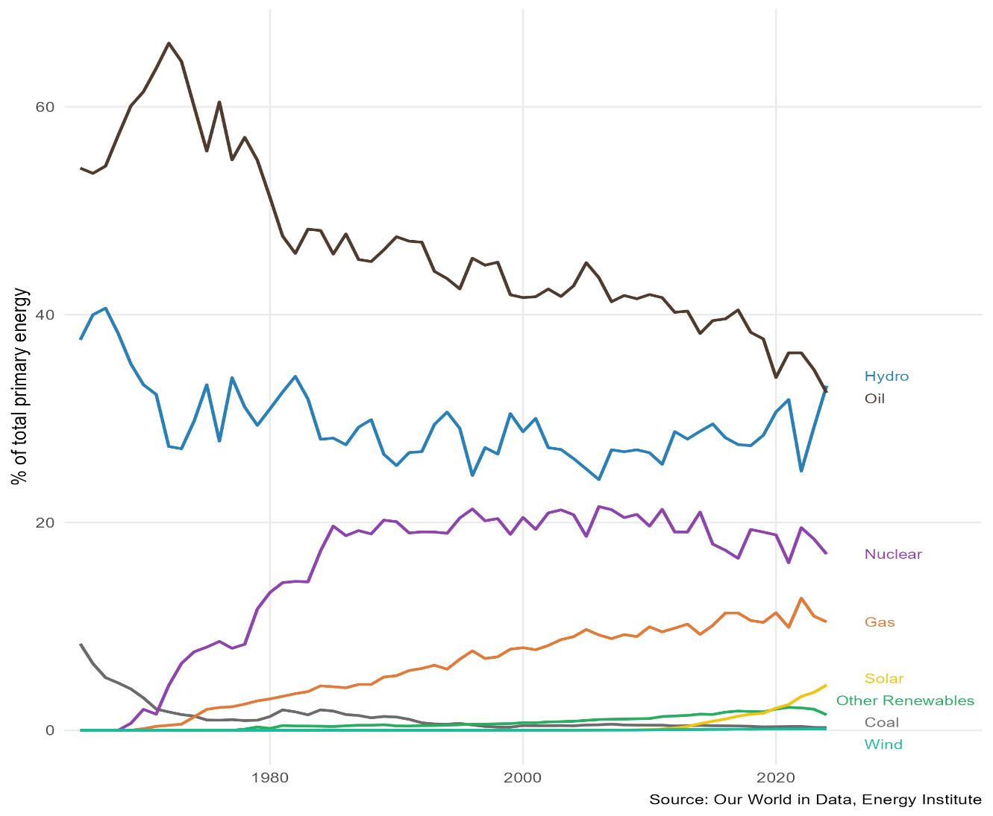
An important systemically significant sector which deserves close attention is the Electricity & Gas sector and more generally the energy sector. In terms of energy source, Switzerland is characterized by a well-diversified energy mix which makes the country relatively less dependent on fossil energy sources compared to other countries.
Figure 6: Share of primary energy use by source in Switzerland (measured as a percentage of total energy supply). Data source: Our World in Data, Energy Institute.
Figure 4 shows Switzerland’s share of energy consumption by source, measured in percentage of total energy supply. Even though Switzerland’s main energy source comes from oil, its share in terms of total primary energy consumption has declined substantially in the last decades, so much that hydropower has become since 2024 the country’s principal energy source. While Switzerland is often regarded as a country deprived of any natural resources, it benefits from abundant water resources which represent a key indigenous asset. The use of water as a power resource goes back to the first industrial revolution, when hydropower was preferred over the steam engine as the driving source of power for industrialization. The choice of hydropower over the steam engine was a consequence of the quasi-absence of domestic coal resources and the high transport costs which made imports of coal very expensive.
The choice of hydraulic power as the driving force during the Industrial Revolution had major consequences for Switzerland's economic and social development. Swiss factories, particularly those in the textile industry, became dispersed throughout rural areas along rivers and streams. For a long time, this rural character of Swiss industry allowed industrialists to keep wages very low, since workers could obtain food and other necessities at low cost or even produce part of their own subsistence. This decentralized pattern of industrialization also slowed the emergence of the trade union movement. The limited energy capacity of hydropower compared to the steam engine furthermore explains why Swiss entrepreneurs specialized into the production of light commodities such as embroidery, textiles, ribbons, silk or watchmaking and jewelry-making.
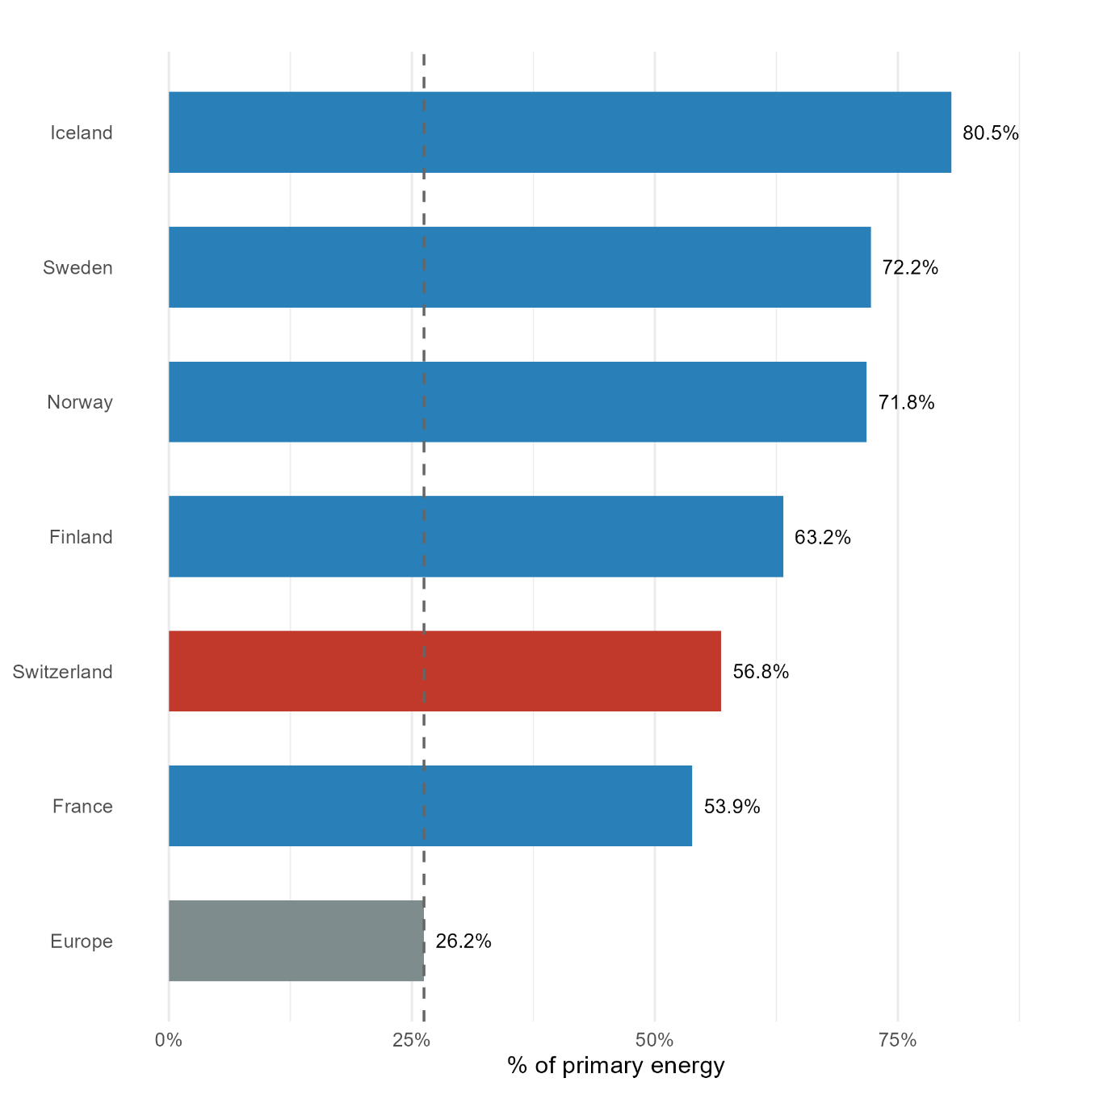
Industrial use of hydropower henceforth created a path dependency into the production of high value added light manufactures which resisted to drastic increase in coal imports after the railway revolution in the second half of the 19th century, which were mainly use outside of private industries (Humair and Chachereau 2024). Hydropower generates nowadays around 58% of the country’s electricity and used to generate 90% of total electricity before the adoption nuclear power in the 70s (figure 4), whose emergence also contributed to lower Switzerland’s strong energy mix. As a result, the share of low carbon energy in Switzerland (56,8%) is by far better compared than Europe (26,2%). With respect to inflation, there is evidence that a high share of renewable sources in energy production helps to increase an economy’s resistance to external price shocks (Markowski and Kotliński 2023). However, Switzerland’s low inflation cannot be explained solely by its efficient energy mix as Northern European countries have higher inflation rates than Switzerland despite having a lower share of carbon energy (figure 5). Along with the energy mix, two other factors need to be taken into account: the regulation of the Swiss electricity market and the low energy intensity of the Swiss economy.
Figure 7: Share of low carbon energy (2024). Source: Our World in Data, Energy Institute.
Regarding the former, electricity supply for private households in Switzerland is not governed by a liberalized market as in the rest of Europe. Consumers purchase their electricity from a local utility provider which is only allowed to adjust electricity tariffs once a year, tariffs which are determined based on their actual production and procurement cost. Nordic countries, despite their better energy mix, are integrated into the European energy market, where wholesale electricity prices are influenced by the merit-order principle, under which the market price is determined by the cost of the marginal kilowatt-hour supplied to the market.
Finally, the resistance of Switzerland’s prices to international energy shocks stems from its very low energy intensity. With only 0,45 kilowatt-hours produced per unit of output, Switzerland is the most energy efficient country among developed economies, far above Northern European countries (which had, as we saw, a lower share of carbon energy), France (0,86), Germany (0,8) or Austria (0,77) (Ritchie and Rosado 2025). Switzerland’s low energy intensity can be explained by a structural and intensity effect. Structural change in the last decade was driven by an important expansion of the pharmaceutical sector, which tends to be generally more energy efficient than other sectors. During the 2010s, the share of the Swiss pharmaceutical sector in the gross value added in the Swiss industrial sector grew from 15% to 31%. Energy intensity declined by 35% in the Swiss manufacturing industry over the same period (Gorgels et al. 2024). However, as argued by Gorgels et al. (2024), the low Swiss energy intensity is not only the result of a structural advantage in the distribution of value added across sectors, but is also a consequence of a decrease in energy intensity within the sectors, meaning that its energy efficiency is pervasive across all sectors of the economy (primary, secondary, tertiary and household sectors).
The Swiss economy is thus very resilient to international energy shocks thanks to a combination of institutional, structural and technical factors. Simulation results from a multi-regional price-quantity input-output analysis by Fernández-Amador et al. (2025) showed that a global price increase of 100% in oil and gas results in only a 1,78% increase in the national price level. However, the responses to such an energy shock are heterogenous across cantons. The canton of Ticino, Neuchâtel are for instance more vulnerable to energy price shocks as they host important refineries of precious metals.

The socio-political coalition behind the island of high prices
Switzerland’s high price island is often regarded as a double-edged sword. On the one hand, the elevated price level insulates Swiss price dynamics from international fluctuations and external shocks. On the other hand, the high price level is seen as the result of market distortions stemming from excessive regulations and protectionism, as well as insufficient competition in sectors geared toward the domestic market (Schaller 2008). The Swiss high price island mirrors the dual character of its economy between, on the one hand, highly competitive and internationalized sectors (for instance multinational companies in finance or industry) which benefit from price stability, and on the other hand the domestic-oriented sectors which remain protected from international competition or is highly cartelized and concentrated (as retail and agriculture) (Mach and Trampusch 2011).
This dualist structure of the Swiss economy has shaped the evolution of Swiss capitalism into a hybrid system characterized by both liberal and coordinating institutions through the early emergence of powerful business interest association (BIAs) which play an active role in Swiss politics. A telling example is the fact that the director of the Swiss Federation of Commerce and Industry (Economiesuisse, previously Vorort), which is the largest BIA in Switzerland and represents the interests of the large export-oriented industries, was generally seen as the eighth federal councillor (Bassin and Noghero 2022). The sheltered sectors producing for the domestic market are for their part represented by Swiss Industry and Trade Association (Gewerverband). Three other important BIAs are the Swiss employers’ Association, which represent the same interests as Economiesuisse but deal mostly with labour market and social policy issues; the Swiss Bankers’ Association which represent and organize financial and banking interests; and the Swiss Farmers’ Union (Bauernverband) which represents the agricultural sector. These five main BIAs defend conflicting business interests. On the side of export-oriented industries, Economiesuisse supports free-trade, low tariff rates, competition policies, minimalistic welfare state and a small degree of labour protection and state intervention into the economy. On the side of sheltered sectors, the Gewerverband and the Swiss Farmers’ Union defend the interests of the domestic-oriented firms which are less competitive and thus demand protection from international competition through protectionist measures or state subsidies (as we have seen with the agricultural sector). Another traditional cleavage among business interests concerns the division between the financial and industrial sectors on monetary policy as the strength of the Swiss franc is regularly seen as a threat by export-oriented industries (Eichenberger and Mach 2011). However, these differentiated interests did not prevent the formation of a long-lasting political coalition between the main BIAs (Economiesuisse, Bauernverband and Gewerverband) and the major right-wing parties: the Free Democratic Party (FDP), the Christian Democratic Party (now The Center) and the Party of Farmers, Traders and Independents (now the Swiss People’s Party SVP). This coalition, often called the “bourgeois bloc” (Mach 2007) or “bourgeois-peasant bloc” (Charles and Vallet 2024, 2025) rested on a political compromise based on external liberalization with domestic compensation. Selective protectionism was for instance key to meet the expectations of both export-oriented industries while sheltering domestic-oriented firms (Mach 2007).
A bourgeois bloc interpretation of the Swiss high-price island would go as follows: price stability at the expense of a high price level can be explained by the domestic compensation measures implemented by the bourgeois bloc to guarantee its cohesion as the support from firms oriented towards the domestic market was key for the bloc’s stability. This hypothesis rests on the assumption that the Swiss price island is the result of an abundance of protectionist regulations and weak competition policy of the domestic sectors. However, as shown by Sax and Weder (2009), the degree of regulations does not have any explanatory power behind the Swiss high price level while the degree of openness along with the long-run improvement of the Swiss terms of trade have positively impacted the real exchange rate. The high level of prices in Switzerland is therefore not so much the result of policy making in favor of the interests of the industries and sectors producing for the national market as it is a consequence of the growing internationalization of the Swiss economy, which is promoted by the competitive export-oriented industries. Ironically, it is these same industries that, through their political representatives, regularly denounce what they considered as excessive regulations and price administration as being responsible for Switzerland’s high price level. Peter Katzenstein, in his famous study of Swiss liberal democratic corporatism, once stated that “The problems that Switzerland confronts in the international economy are problems of success: the management of monetary stability in a world of inflation and the viability of an export industry hit hard by the appreciation of the Franc” (Katzenstein 1980, 508). The Swiss high price island is the symptom of such “problems of success” as it reflects the success of its export-oriented industries in the context of increasing internationalization. However, problems of success are only one side of the story because, as we have seen, real estate is the most systemically significant sector of the Swiss economy and the housing crisis has substantially contributed to elevating the price level in the last decades.

Conclusion
In summary, several factors explain the resistance of the Swiss economy to inflation. First, price administration helps to shelter prices from international fluctuations in key sectors for price stability such as electricity, transport or food manufacturing. Second, the high share of nuclear and hydropower energy in the Swiss energy mix, as well as the country’s low energy intensity help to further strengthen its resistance to shockflation emanating from oil or gas shocks. Third, some key domestic sectors are heavily regulated and protected from the international economy, or are strongly cartelized, as we have seen with the example of the Migros-Coop duopoly and the sheltered agricultural sector. While this helps to insulate domestic prices from international pressures, the high degree of protection, regulation and cartelization of the domestic economy has often being accused of making Switzerland a island of high prices. We have shown that the latter is not so much the consequence of the protection of the industries and sectors producing for the national market as it is a consequence of the growing internationalization of the Swiss economy, which is promoted by the competitive export-oriented industries. In conclusion, accusing the high degree of protection and cartelization of the domestic economy is largely a case of not seeing the forest for the trees as Switzerland’s high price level originates from other more important factors such as the housing crisis and the increasing internationalization of the Swiss economy. Our key finding is that there is no trade-off between high prices and inflation, and that the factors which contribute to the high price level are not the same that keep inflation low.

References
Albouy, Martin, and Gilles Bordes. 2026. “The Swiss High-Price Island.” Direction générale du Trésor. https://www.tresor.economie.gouv.fr/Articles/2026/01/22/the-swiss-high-price-island.
Auer, Raphael, Ariel Burstein, and Sarah M. Lein. 2021. “Exchange Rates and Prices: Evidence from the 2015 Swiss Franc Appreciation.” American Economic Review 111 (2): 652–86. https://doi.org/10.1257/aer.20181415.
Auer, Simone, Simon Beyeler, and Jonas Meier. 2025. How Large Is the Impact of Administered Prices on Inflation in Switzerland? No. 10/2025. Swiss National Bank. https://www.snb.ch/en/publications/research/economic-notes/2025/economic_note_2025_10.
Bachmann, Andreas. 2012. Exchange Rate Pass-through to Various Price Indices: Empirical Estimation Using Vector Error Correction Models. Working Paper Nos. 12–05. Discussion Papers. https://www.econstor.eu/handle/10419/76750.
Baltensperger, Ernst. 2023. “The Return of Inflation.” Swiss Journal of Economics and Statistics 159 (1): 10. https://doi.org/10.1186/s41937-023-00114-x.
Baltensperger, Ernst, and Peter Kugler. 2016. “The Historical Origins of the Safe Haven Status of the Swiss Franc.” Aussenwirtschaft 67 (2): 1–30.
Bassin, Aline, and Fanny Noghero. 2022. Les cinq chantiers économiques du nouveau Conseil fédéral. December 8. https://www.letemps.ch/economie/cinq-chantiers-economiques-nouveau-conseil-federal.
Charles, Léo, and Guillaume Vallet. 2024. “Fast and Curious: ‘The Swiss Development Puzzle’. The Institutional Roots of the Success of Industrialization.” Review of Political Economy 0 (0): 1–27. https://doi.org/10.1080/09538259.2023.2298747.
Charles, Léo, and Guillaume Vallet. 2025. “Le bloc social aux origines du capitalisme de la Suisse et son succès de long terme:L’exemple des industries exportatrices suisses, 1848-1936.” Revue de l’OFCE 190 (3): 85–112. https://doi.org/10.3917/reof.190.0085.
Dullien, Sebastian, David Gallusser, and Silke Tober. 2024. Historische Preissteigerungen in Deutschland, niedrige Inflation in der Schweiz: Die Rolle von Regulierung. Working Paper No. 224. IMK Working Paper. https://www.econstor.eu/handle/10419/302161.
Eichenberger, Pierre, and André Mach. 2011. “Organized Capital and Coordinated Market Economy: Swiss Business Interest Associations between Socio-Economic Regulation and Political Influence.” In Switzerland in Europe. Routledge.
Eurostat. 2026. “Food Price Monitoring Tool.” Eurostat. https://doi.org/10.2908/PRC_FPMT_M.
Fatum, Rasmus, and Yohei Yamamoto. 2016. “Intra-Safe Haven Currency Behavior during the Global Financial Crisis.” Journal of International Money and Finance, The New Normal in the Post-Crisis Era, vol. 66 (September): 49–64. https://doi.org/10.1016/j.jimonfin.2015.12.007.
Fernández-Amador, Octavio, Doris A. Oberdabernig, and Patrick Tomberger. 2025. “Measuring Regional Integration into Global Supply Chains: Evidence from a New Dataset of Swiss Cantons.” Swiss Journal of Economics and Statistics 161 (1): 3. https://doi.org/10.1186/s41937-025-00134-9.
Fischer, Silvan, Michael Grass, Bruno Grossmiklaus, and Valentino Guggia. 2021. “Analyse Der Schweizer Detailhandelspreise Im Internationalen Vergleich.” BAK Economics. https://www.bak-economics.com/studien-analysen/detail/analyse-der-schweizer-detailhandelspreise-im-internationalen-vergleich.
Goldztejn, Dimitri. 2024. Cost-Push and Conflict Inflation: The Case of France between 2021 and 2023. Working Paper No. 110. FMM Working Paper. https://www.econstor.eu/handle/10419/324475.
Gorgels, Stefan, Maria Polugodina, and Sevrin Waights. 2024. “Was Erklärt Die Tiefe Energieintensität Der Schweizer Wirtschaft?” Staatssekretariat für Wirtschaft SECO. https://www.seco.admin.ch/seco/fr/home/Publikationen_Dienstleistungen/Publikationen_und_Formulare/Strukturwandel_Wachstum/Strukturwandel/wp_48.html.
Herger, Nils. 2012. “Exchange Rates and Import Prices in Switzerland.” Swiss Journal of Economics and Statistics 148 (3): 381–407. https://doi.org/10.1007/BF03399371.
Hillen, Judith. 2019. “Market Integration and Market Efficiency under Seasonal Tariff Rate Quotas.” Journal of Agricultural Economics 70 (3): 859–73. https://doi.org/10.1111/1477-9552.12355.
Hockett, Robert C., and Saule T. Omarova. 2016. “Systemically Significant Prices.” Journal of Financial Regulation 2 (1): 1–20. https://doi.org/10.1093/jfr/fjw007.
Honohan, Patrick. 2024. “The Inflation Surge in Europe.” SSRN Scholarly Paper No. 4875072. Social Science Research Network, May 28. https://doi.org/10.2139/ssrn.4875072.
Humair, Cédric, and Nicolas Chachereau. 2024. L’énergie en Suisse: de 1800 à nos jours. Première edition. Savoir suisse 179 Histoire. Presses polytechniques et universitaires romandes.
Ipsen, Leonhard, Armin Aminian, and Jan Schulz. 2025. “Stress-Testing Inflation Exposure: Systemically Significant Prices and Asymmetric Shock Propagation in the EU.” Structural Change and Economic Dynamics 74 (September): 713–24. https://doi.org/10.1016/j.strueco.2025.05.010.
Katzenstein, Peter J. 1980. “Capitalism in One Country? Switzerland in the International Economy.” International Organization 34 (4): 507–40. https://doi.org/10.1017/S002081830001883X.
Kluser, Frédéric. 2025. “Cross-Border Shopping: Evidence from Household Transaction Records.” Swiss Journal of Economics and Statistics 161 (1): 9. https://doi.org/10.1186/s41937-025-00141-w.
Lee, Kang-Soek. 2017. “Safe-Haven Currency: An Empirical Identification.” Review of International Economics 25 (4): 924–47. https://doi.org/10.1111/roie.12289.
Leutert, Jessica, Rolf Scheufele, and Selina Schön. 2026. “Wage-Price Pass-through in Switzerland.” Swiss Journal of Economics and Statistics 162 (1): 2. https://doi.org/10.1186/s41937-026-00148-x.
Mach, André. 2007. “La Redéfinition Du Block Bourgeois Au Cours Des Vingt Dernières Années.” In Zur Politischen Ökonomie Der Schweiz: Eine Annäherung ; Analysen Und Impulse Zur Politik ; Jahrbuch Denknetz 2007: Une Approche ; Analyses et Impulsions Politiques ; Cahier Réseau de Réflexion 2007 = La Politique Économique de La Suisse, 1. Aufl. Jahrbuch / Denknetz, 3.2997. Zürich.
Mach, André, and Christine Trampusch. 2011. “The Swiss Political Economy in Comparative Perspective.” In Switzerland in Europe. Routledge.
Markowski, Łukasz, and Kamil Kotliński. 2023. “Renewables, Energy Mix and Inflation in the European Union Countries.” Energies 16 (23): 7808. https://doi.org/10.3390/en16237808.
Mergele, Lukas, Damian Wehrli, and Nils Winistörfer. 2026. “Administriete Preise.” Grundlagen Für Die Wirtschaftspolitik (Bern), no. 62.
Morschett, Dirk, Thomas Rudolph, Johannes Bauer, Annett Donnath, and Niklas Meise. 2009. “Retailing in Switzerland - Player, Strategies and Developments.” European Retail Research 23 (2): 163–90.
Nod, Ursula, and Mario Irminger. 2026. Rapport Annuel Migros 2025. Fédération des coopératives Migros. https://report.migros.ch/2025/app/uploads/Rapport-de-gestion.pdf.
OECD. 2025. “Agricultural Policy Monitoring and Evaluation 2025: Making the Most of the Trade and Environment Nexus in Agriculture.” Agricultural Policy Monitoring and Evaluation 2025 (October). https://doi.org/10.1787/a80ac398-en.
Oktay, Alex. 2022. “Heterogeneity in the Exchange Rate Pass-through to Consumer Prices: The Swiss Franc Appreciation of 2015.” Swiss Journal of Economics and Statistics 158 (1): 21. https://doi.org/10.1186/s41937-022-00102-7.
Reynard, Samuel. 2009. “What Drives the Swiss Franc?” Aussenwirtschaft 64 (3): 335–63.
Ritchie, Hannah, and Pablo Rosado. 2025. “Switzerland Country Profile. Energy.” Our World in Data, December 19. https://ourworldindata.org/profile/energy/switzerland.
Sax, Christoph, and Rolf Weder. 2009. “How to Explain the High Prices in Switzerland?” Swiss Journal of Economics and Statistics 145 (4): 463–83. https://doi.org/10.1007/BF03399292.
Schaller, Francois. 2008. L’île de cherte: Chronique d’un délire économique collectif suivi de L’éternel retour des crises financières - Anthropologie de la destruction de valeur. SLATKINE.
Sonnenberg, Nils. 2022. Zu den Inflationsunterschieden zwischen der Schweiz, Spanien und Deutschland. https://www.econstor.eu/handle/10419/265303.
Stulz, Jonas. 2007. “Exchange Rate Pass-through in Switzerland: Evidence from Vector Autoregressions.” Swiss National Bank Economic Studies (Zürich) 2007 (4).
Sturm, Jan-Egbert, Alexander Rathke, Klaus Abberger, et al. 2023. “Konjunkturanalyse: Prognose 2024 / 2025 Schweizer Wirtschaft im Sog der internationalen Konjunkturschwäche.” KOF Analysen (Zürich) 2023 (4): 1–30. https://doi.org/10.3929/ethz-b-000651951.
Sutter, Joos, and Philipp Wyss. 2026. Rapport de Gestion 2025. Groupe Coop. https://report.coop.ch/pdfs/Coop_GB_25_FR_5ec1838f7e.pdf.
Tschirren, Martin. 2026. “La pénurie de logements se poursuit.” La Vie économiques. https://dievolkswirtschaft.ch/fr/2026/03/la-penurie-de-logements-se-poursuit/.
Vallet, Guillaume. 2016. “The Role of the Swiss Franc in Switzerland’s European Stance.” Research in International Business and Finance 38 (September): 35–44. https://doi.org/10.1016/j.ribaf.2016.03.017.
Weber, Isabella M., Jesus Lara Jauregui, Lucas Teixeira, and Luiza Nassif Pires. 2024. “Inflation in Times of Overlapping Emergencies: Systemically Significant Prices from an Input–Output Perspective.” Industrial and Corporate Change 33 (2): 297–341. https://doi.org/10.1093/icc/dtad080.
Weber, Isabella M., Jan-Erik Thie, Jesus Lara Jauregui, and Lucas Teixeira. 2026. “Carbon Prices and Inflation in a World of Shocks: Systemically Significant Prices and Industrial Policy Targeting in Germany.” Energy Policy 217 (October): 115395. https://doi.org/10.1016/j.enpol.2026.115395.
WTO. 2024. World Tariff Profiles 2024. WTO iLibrary. https://doi.org/10.30875/9789287076519.

PhD candidate in political economy, department of history-economics-society, University of Geneva. celal.gueney@unige.ch.
PhD candidate in political economy, department of history-economics-society, University of Geneva.
Professor, department of history-economics-society, University of Geneva.
For a summary of the empirical estimates of the ERPT effects in Switzerland, see Bachmann (2012).
For instance: SportX, Micasa and Melectronics (a sports retailer, a furniture retailer, and an electronics retailer)
https://www.rts.ch/info/economie/14379498-les-marges-spectaculaires-des-grands-distributeurs-coop-et-migros.html
According to Fischer et al. (2021)’s estimations, this increase in the food-only retail price index is strongly driven by

